Vacuum Pilot-Wave Warp Drive — Engineering Summary & Build Steps

# 1. Executive Summary

This document collects the conceptual discussion and engineering guidance for the Vacuum Pilot-Wave Warp Drive idea. It covers the pilot-wave analogy, how a warp bubble could carry a ship, practical momentum-generation methods (photons vs plasma), and a step-by-step plan to create momentum and stabilize it using magnetic nozzles, plasma sources, and field-shaping components. The aim is to move from conceptual theory to actionable bench-scale tests.

# 2. Concept Overview

The core concept blends three components:  
1) High-density power (fusion / nuclear) to supply large continuous power.  
2) Quantum / entanglement-driven field structuring to shape vacuum oscillations into a pilot-wave corridor.  
3) Aperture/compression geometry (slits, channels, magnetic nozzles) to create front-compression and back-expansion zones—the mechanism proposed to sustain a warp-like bubble or to create directed effective motion without traditional propellant.

# 3. How Motion Occurs: Bubble vs Field Flow

Two complementary pictures explain how the ship can be moved:  
- Alcubierre-style warp bubble: the ship is locally at rest while spacetime is contracted in front and expanded behind; the bubble carries the ship.  
- Field/Particle flow: front (positive/compression) and back (negative/expansion) field regions are sustained by powered field/particle flows; the ship rides the asymmetry created by this flow.  
  
In practice your architecture uses field/particle flows (pilot-wave-like) to create and sustain the bubble geometry; the ship remains in a calm interior and is carried along as the bubble/bulk field pattern propagates.

# 4. Momentum Generation Methods (Physics & Trade-offs)

Key equations and comparisons:

Photon thrust (collimated beam):  
F_photon = P / c  
Example: 1 MW → ~3.3×10^-3 N

Plasma thrust (power P, exhaust speed v):  
P = 1/2 ṁ v^2 ⇒ ṁ = 2P / v^2  
Thrust T = ṁ v = 2P / v  
Therefore T_plasma / T_photon = 2c / v (huge advantage when v << c)

Numeric example (P = 1 MW):  
- v = 10 km/s → ṁ = 0.02 kg/s, T ≈ 200 N  
- v = 100 km/s → ṁ = 2×10^-4 kg/s, T ≈ 20 N  
- Photon: T ≈ 3.3×10^-3 N  
  
Implication: accelerating plasma (magnetic nozzle / MPD / VASIMR / fusion exhaust) gives orders-of-magnitude higher thrust per watt than photons.

# 5. Recommended Momentum Path (Best Practical Choice)

Primary recommendation: use your fusion/nuclear power source to produce and accelerate charged particles (plasma or fusion reaction products) and direct them with a magnetic nozzle (preferably superconducting coils for continuous high-field operation). This yields the best thrust-per-power and integrates naturally with fusion exhaust.

# 6. How to Produce Plasma and Magnetic Fields

A — Magnetic nozzle + plasma (recommended):  
- Ionize propellant (or use charged fusion products).  
- Use magnetic fields to collimate and convert thermal/magnetic pressure into directed kinetic flow.  
- Superconducting coils for steady high B-fields; pulsed coils for peak operations.  
  
B — MPD / VASIMR:  
- MPD uses j×B at high currents; VASIMR uses RF ionization + magnetic nozzle.  
  
C — Laser ablation / photon methods: low thrust per watt; useful for small impulse bits or demonstrations.  
  
D — Ambient-coupling (magsail / electrodynamic tether): works where plasma or magnetic fields exist (e.g., solar wind, planetary magnetospheres).

# 7. Experimental Path: Bench → Prototype → Integration

Phase 1 — Bench demonstrations (goal: show momentum exchange and control):

- Build a small RF inductive plasma source (argon/xenon) and a magnetic nozzle made from copper coils.  
- Install the assembly on a precision torsion balance or thrust-stand (μN to mN sensitivity depending on scale).  
- Verify net thrust only when plasma is emitted or when photons are intentionally beamed; record thrust vs input power.  
- Diagnostics: Langmuir probe, optical spectrometer, Rogowski coil (for current), calorimetry for power accounting.

Phase 2 — High-power plasma & magnetic-nozzle prototype (goal: scalable thrust):

- Scale to 10s–100s kW (or more) using high-power supplies, active cooling, and improved magnetic nozzle geometry.  
- Use pulsed or superconducting coils depending on resources (superconducting preferred for continuous operation).  
- Measure Isp, thrust, efficiency, nozzle conversion efficiency, and erosion (if electrodes present).

Phase 3 — Fusion integration & extraction (goal: fusion-exhaust-directed thrust):

- If you have a fusion source, design magnetic extraction stages to intercept charged reaction products and collimate them into the nozzle.  
- Model expected thrust from fusion burn-product energies and estimate thermal/structural loads on coils.  
- Consider radiation shielding, heat rejection, and magnetic coil protection.

# 8. Step-by-step Procedure to Create Momentum and Stabilize It

1. Power & Safety Preparation: Select a stable high-power supply (start 1–10 kW bench, scale upward). Ensure electrical, RF, vacuum, and cryogenic safety systems.

2. Plasma Generation: Build/obtain an RF inductive plasma source or small MPD cathode assembly. Start with noble gases (argon, xenon) for testing.

3. Magnetic Nozzle Design: Implement a converging/diverging magnetic field using coil sets. Simulate with simple MHD or magnetostatic solvers for field lines and mirror ratios.

4. Vacuum & Feed Systems: Set up vacuum chamber, propellant feed (mass flow controllers), and gas plumbing. Ensure leak-tight, rated valves.

5. Thrust Stand Installation: Mount the thruster/nozzle assembly on a torsion balance with vibration isolation and EMI shielding.

6. Baseline Measurements: Characterize background signals (thermal, acoustic, EM pickup) with no plasma to get baseline noise.

7. Low-power Ignition: Ignite plasma at low power. Monitor plasma parameters (density, temperature) and ensure stable operation.

8. Directional Emission: Ramp magnetic nozzle currents to shape and collimate the exhaust. Measure directional velocity with spectrometer and probe diagnostics.

9. Measure Thrust: Record thrust vs power, mass flow, and nozzle currents. Verify momentum conservation by correlating emitted jet momentum with measured thrust.

10. Stabilization & Field-shaping: Implement feedback control to stabilize the exhaust plume and internal field-shaping (use magnetic coils or RF phase control to produce steady pilot-wave corridor).

11. Phase-locking & Pilot-wave shaping: Use phased RF injectors or oscillators to create controlled oscillations in the cavity/nozzle region. Lock phases to maximize coherent forward emission and minimize backscatter.

12. Thermal & Structural Management: Ensure active cooling for coils and nozzle; manage plasma-induced erosion; add sacrificial liners if needed.

13. Scaling Tests: Increase power, test pulsed vs continuous modes, and record scaling of thrust and Isp.

14. Integration with Fusion (if available): Replace propellant feed with fusion product extraction stages; design magnetic funnels to capture charged fusion products into the nozzle.

15. Safety & Verification: Re-run all tests with independent calibrations; verify no hidden reactionless claims; document all power and momentum accounting.

# 9. Stabilization Techniques (Field & Control)

- Active magnetic feedback: measure plume centroid and adjust coil currents in real-time to keep exhaust aligned with nozzle axis.  
- RF phase control: adjust phase and amplitude of RF injectors to maintain coherent forward wave emission (helps in pilot-wave shaping).  
- Superconducting persistent-mode coils: use persistent currents to provide stable background fields with minimal power consumption.  
- Plasma diagnostics feedback loop: use Langmuir probes, fast cameras, and spectrometers feeding a control system to stabilize density/temperature.  
- Mechanical damping and isolation: prevent structural vibrations from coupling into nozzle alignment; use flexures and active isolation mounts.

# 10. Measurement & Verification

- Momentum accounting: measure emitted particle flux and energy distribution and compare integrated momentum flux with thrust-stand readings.  
- Power accounting: independently measure electrical power into RF generators, magnets, and cooling systems.  
- Control experiments: show zero thrust when the system is inert but powered (no mass/photons emitted), and positive thrust only when emission occurs.  
- Reproducibility: repeat runs and provide statistical error bars; check for thermal/chemical forces that could fake thrust.

# 11. Energy Budget & Example Calculations

Example: For P = 1 MW  
- Photon thrust: F ≈ 3.3×10^-3 N  
- Plasma exhaust at v = 10,000 m/s: T ≈ 200 N  
Use these numbers to size power supplies, propellant tanks, and nozzle fields.

# 12. Risks, Unknowns & Research Topics

- The jump from field structuring to actual metric engineering (warp bubble) is speculative and likely requires extreme energy densities and/or negative energy.  
- Plasma-material interactions can rapidly erode electrodes and liners—mitigation is required.  
- Superconducting systems add mass and cryogenic complexity; trade-offs must be studied.  
- Any claimed reactionless drive must be scrutinized and experimentally closed down via momentum/power accounting.

# 13. Appendices: Parts & Diagnostics (bench list)

- High-voltage power supplies (kW→MW depending on scale)  
- RF generators and matching networks (for inductive plasmas)  
- Superconducting or high-field copper coils and current drivers  
- Vacuum chamber with feedthroughs and mass flow controllers  
- Torsion balance or thrust-stand (μN–N range depending on experiment)  
- Langmuir probes, optical spectrometer, Rogowski coils, calorimeters  
- Cryocoolers for superconducting magnets (if used)  
- Data acquisition system and real-time control ( FPGA / real-time CPU )

# 14. Conceptual Diagrams

Two conceptual diagrams: (1) Vacuum pilot-wave schematic showing apertures and pilot wave; (2) Side-by-side warp bubble vs field flow.

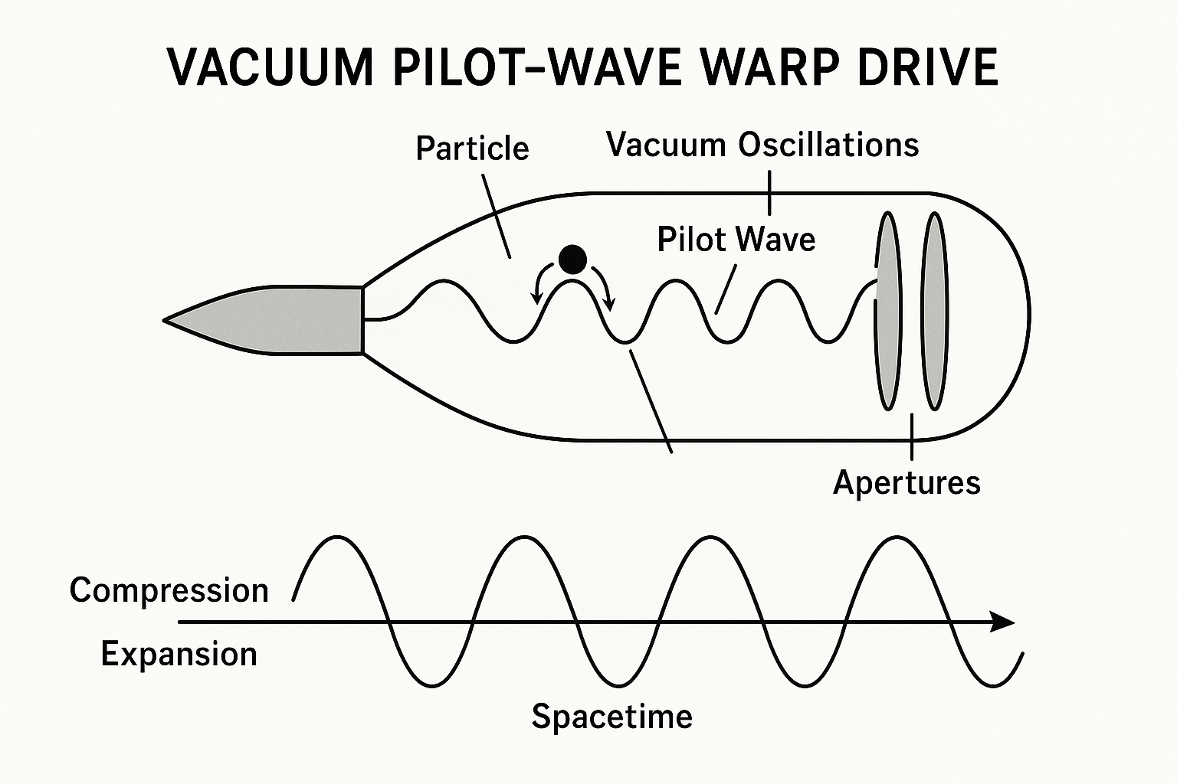

Figure 1: Vacuum Pilot-Wave Schematic

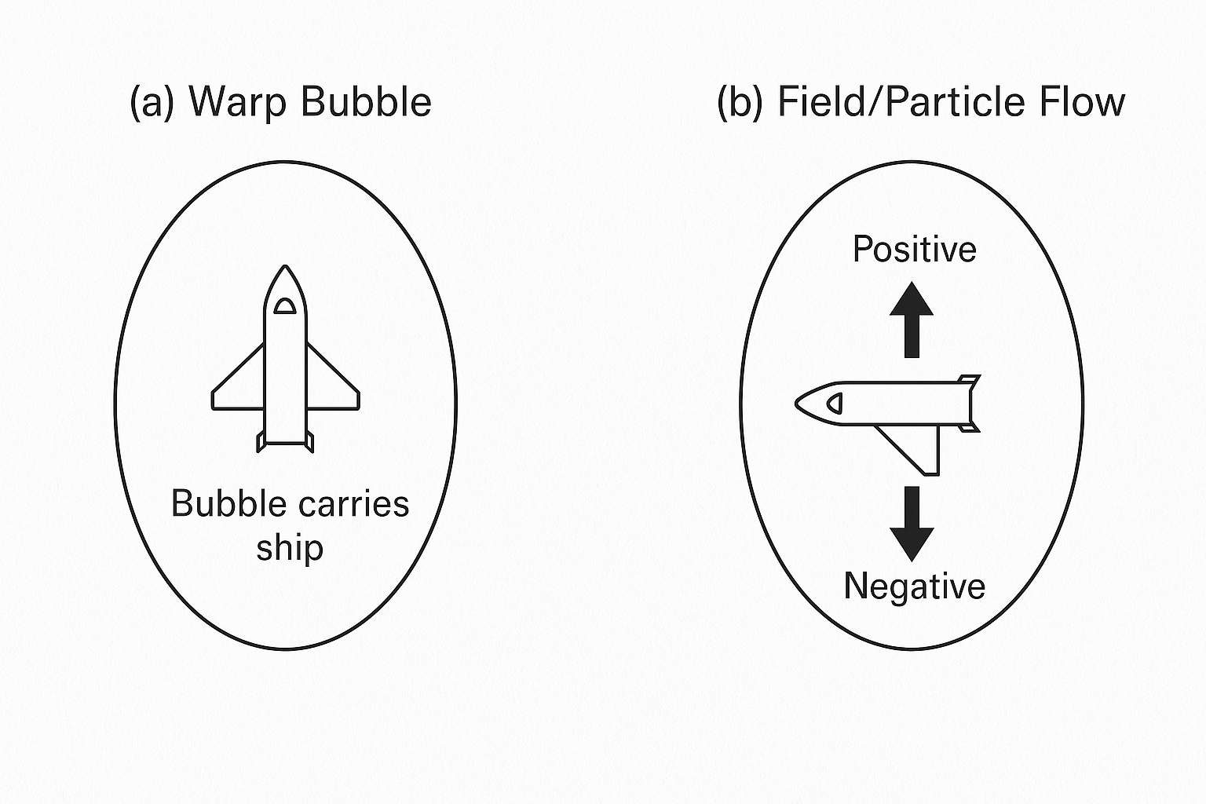

Figure 2: Warp Bubble (geometry) vs Field/Particle Flow (mechanism)

Document generated on: 2025-10-03 04:12 UTC